

|  |  |  |  |  |  |  |  |  |
| --- | --- | --- | --- | --- | --- | --- | --- | --- |
|  | | | | | | | | |
|  | | ****INFORMATION GATHERING AND**** ****EXPLOITATION**** | | | | |  | |
|  |  | | | | | | |  |
|  | | | |  |  | | | |
|  | | | | Sheik Arshad |  | | | |
|  | | | | Date02-03-2022Course titleCS_TALAKUNCHI**PROJECT 2** |  | | | |
|  | | |  | | |  | | |



|  |  |  |  |  |  |  |  |  |
| --- | --- | --- | --- | --- | --- | --- | --- | --- |
|  |  | | |  |  | | |  |
|  | INSTRUCTIONS | | | | | | |  |
|  |  | | |  |  | | |  |
|  |  | |  | | |  | |  |
|  |  |  | **Project submission:**  Take screen shots of each and every task mentioned and make a report of each project in Word format only. | | |  |  |  |
|  | | | | |
|  |  |  |  |
|  |  |



|  |  |  |  |  |  |  |
| --- | --- | --- | --- | --- | --- | --- |
|  | |  |  |  |  | |
|  | | THE PROCESS | | |  | |
|  | |  |  |  |  | |
|  | TASK 1 Take some website (vulnerable website). Scan using OWASP ZAP Tool (quick/automated).  Set of vulnerabilities - make a report with mitigation's | | | | |  |

|  |  |  |  |  |  |  |
| --- | --- | --- | --- | --- | --- | --- |
|  | TASK: 1 | | | | |  |
|  | |  |  |  |  | |
|  |  | | | | |  |

* **Website worked on:**
* <http://testphp.vulnweb.com>

**OWSAP ZAP SCAN**

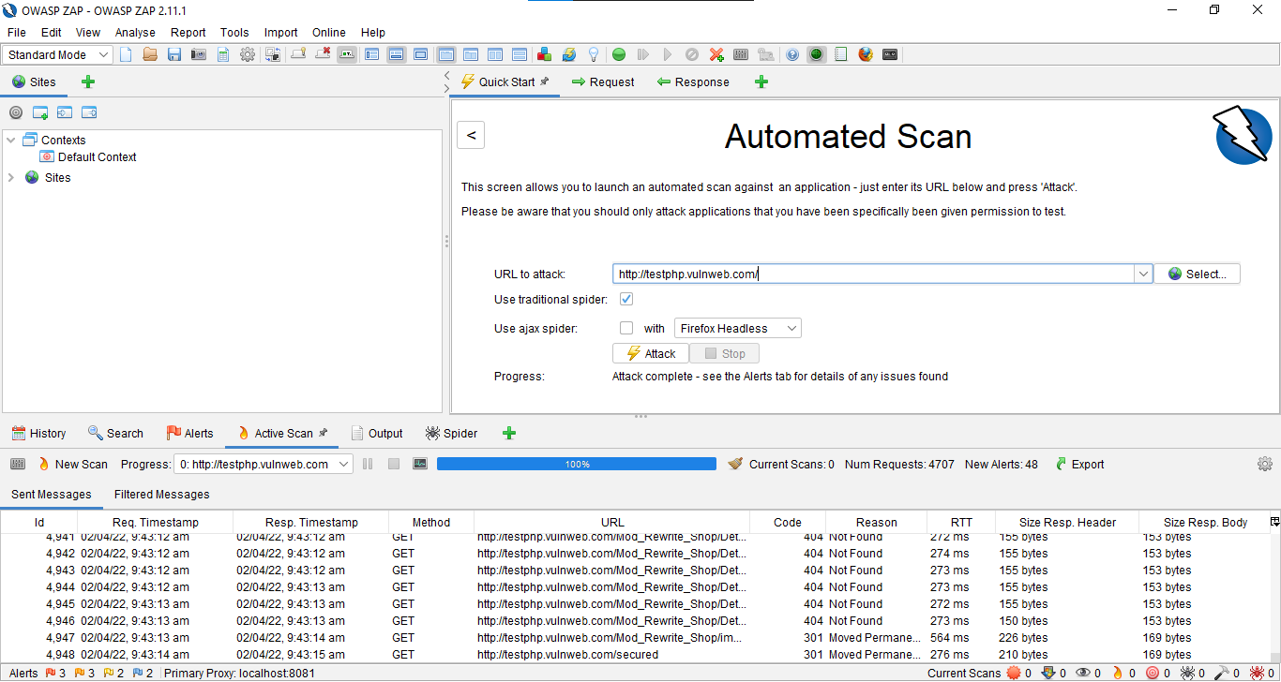

**ALERTS:**

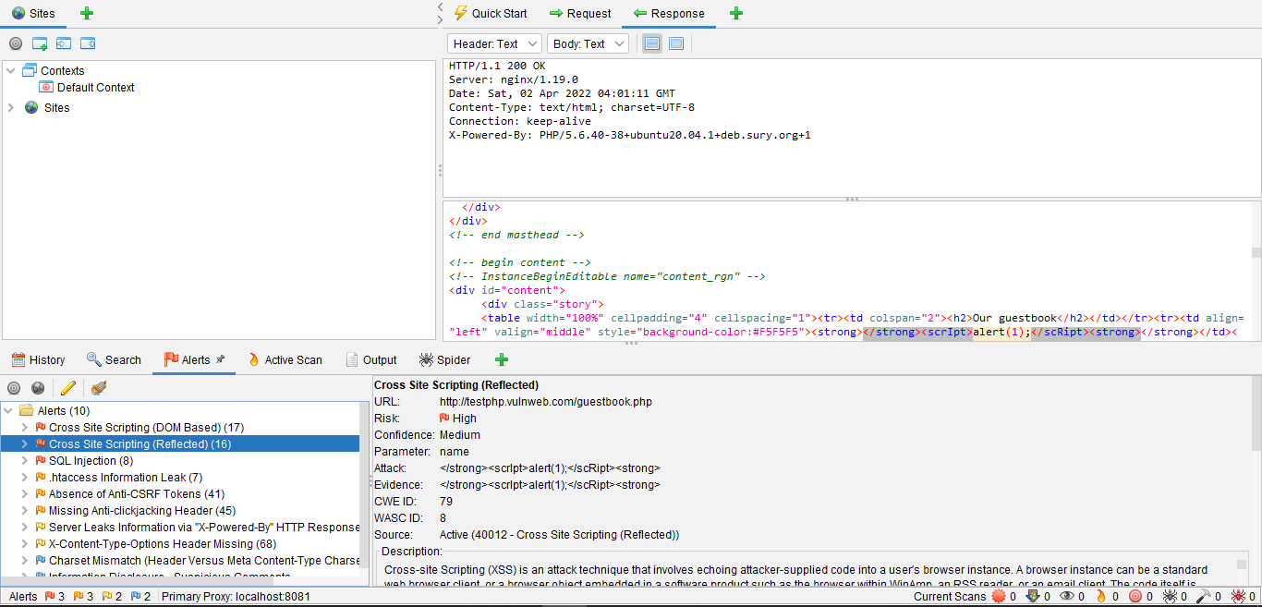

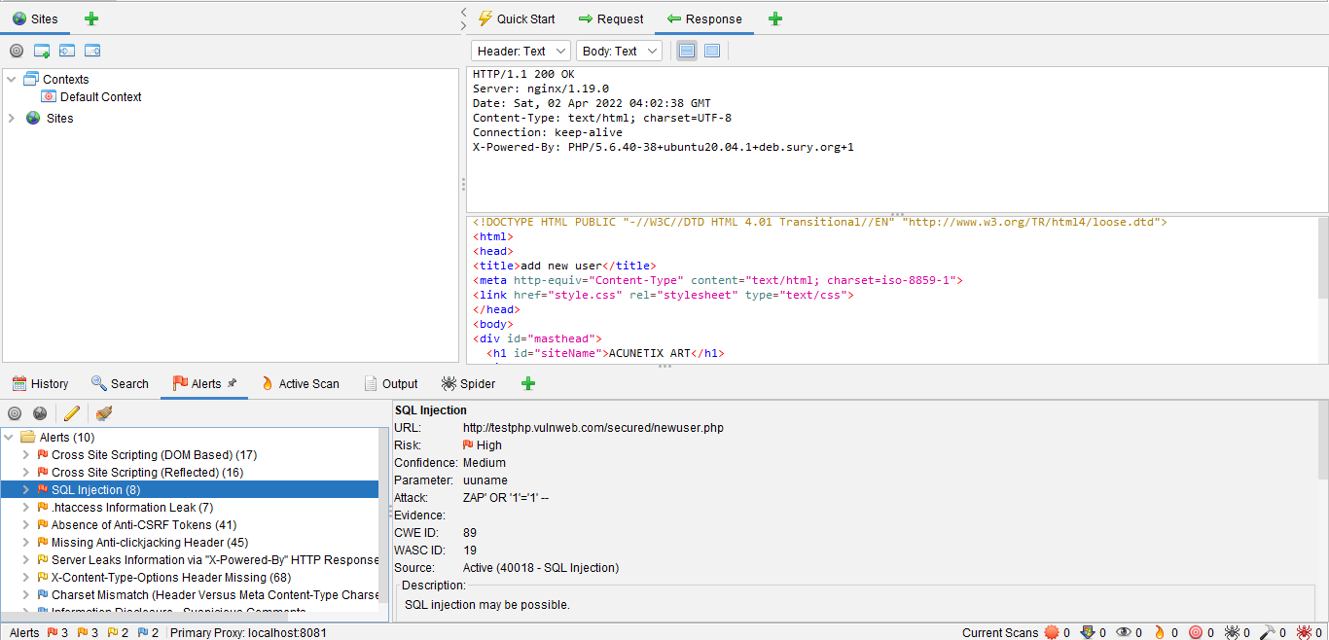

**FINAL REPORT:**



**ALERT DETAILS WITH MITIGATIONS:**

**1.Cross Site Scripting (DOM Based) Risk Level –HIGH**

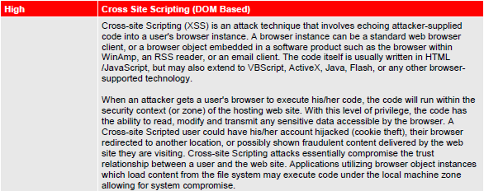

**SOLUTION:**

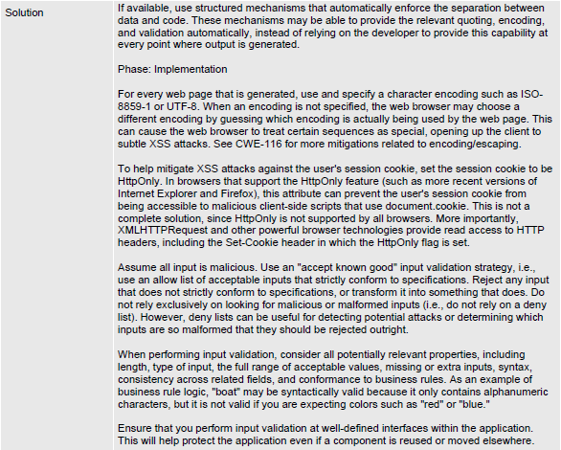

**2.Cross Site Scripting (Reflected) Risk Level - HIGH**

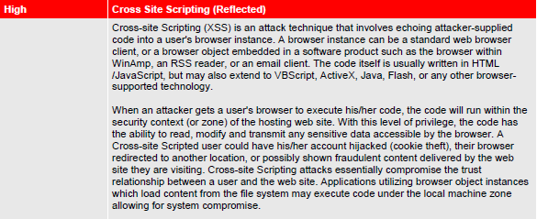

**SOLUTION:**

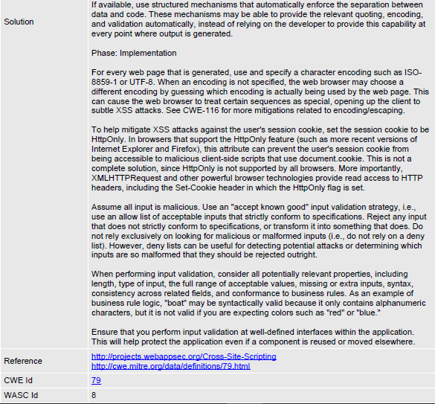

**3. SQL Injection: Risk Level – HIGH**



**SOLUTION:**

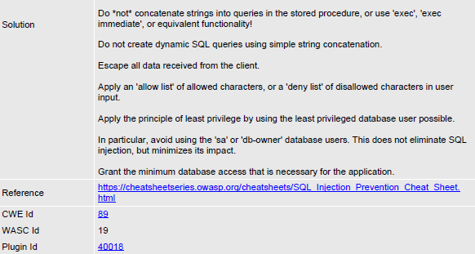

**4 .htaccess Information Leak Risk Level – MEDIUM**



**SOLUTION:**

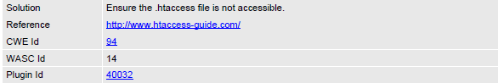

**5. Absence of Anti-CSRF Tokens Risk Level – MEDIUM**

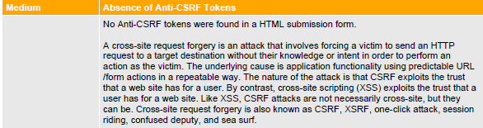

**SOLUTION:**

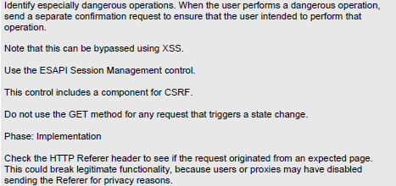

**6. Missing Anti-clickjacking Header Risk Level – MEDIUM**



**SOLUTION:**

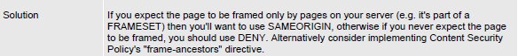

**7. Server Leaks Information via "X-Powered-By" HTTP Response Header Field(s)**

**Risk Level – LOW**

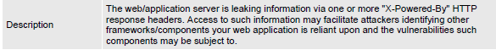

**SOLUTION:**

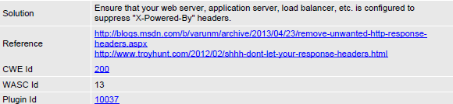

**8. X-Content-Type-Options Header Missing**

**Risk Level – LOW**

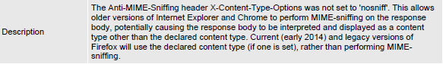

**SOLUTION:**

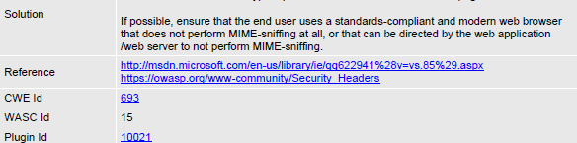

**9. Charset Mismatch (Header Versus Meta Content-Type Charset)**

**Risk Level – INFORMATIONAL**

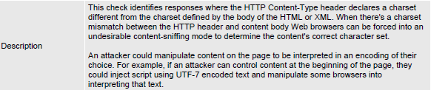

**SOLUTION:**

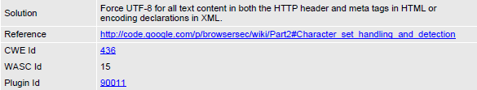

**10. Information Disclosure - Suspicious Comments**

**Risk Level – INFORMATIONAL**

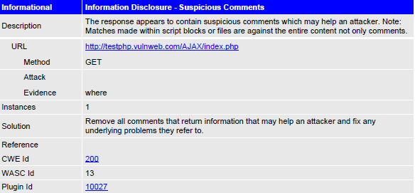

**FOR A DETAILED REPORT OF SCAN AND ATTACKS:**

**Go to :** <https://drive.google.com/file/d/1PorKU8QEnVEjjGX4Nrf-aPA9hiQK1AfV/view?usp=sharing>